Chapter 3 Migration Name: ________________________
Due: __________ Date: ______ Period: _______

- What are 3 reasons given for why people migrate? ________________________________________________________________
- Define emigration: ________________________________________________________________________________________
- Define immigration: _______________________________________________________________________________________
- What is positive migration? _________________________________________________________________________________
Give an example: __________________________________________________________________________________
- What is negative migration? _________________________________________________________________________________
Give an example: __________________________________________________________________________________
- What is meant by circulation? ________________________________________________________________________________
Give an example: __________________________________________________________________________________
- What do people take with them when they migrate? ________________________________________________________________
- __________________ is still important to an individual’s ____________ ___________ & ______________ _______________.
- Who was EG Ravenstein? ____________________________________________________________________________________
- How are his Laws of Migration categorized? ______________________________________________________________________
- Most people migrate for _____________________ reasons.
- What are three push factors and pull factors? With examples
________________________________________________________________________________________________
________________________________________________________________________________________________
________________________________________________________________________________________________
________________________________________________________________________________________________
________________________________________________________________________________________________
________________________________________________________________________________________________
________________________________________________________________________________________________
- Complete the chart below with specific examples of push and pull factors and where people are being pushed from and pulled to.
--also provide historical/real world examples:

 | Push Factors | Pull Factors
Economic
Cultural
Environmental

- Define intervening obstacle and give several examples: _____________________________________________________________
________________________________________________________________________________________________
________________________________________________________________________________________________
________________________________________________________________________________________________
________________________________________________________________________________________________
- In the past the IO was primarily ___________________. For example: ________________________________________________
- Briefly describe the role of physical geography in examining intervening obstacles and migration. ______________________________
________________________________________________________________________________________________
________________________________________________________________________________________________
________________________________________________________________________________________________
- __________________________ improvements have facilitated globalization.
- Briefly describe the role of transportation in examining intervening obstacles and migration.
________________________________________________________________________________________________
________________________________________________________________________________________________
________________________________________________________________________________________________
- Briefly describe the role of political concerns/laws in examining intervening obstacles and migration.
________________________________________________________________________________________________
________________________________________________________________________________________________
________________________________________________________________________________________________
- What two points did Ravenstein make concerning distance of migration?
________________________________________________________________________________________________
________________________________________________________________________________________________
________________________________________________________________________________________________
- Migration may be classified as either international or internal. What is the difference?
________________________________________________________________________________________________
________________________________________________________________________________________________
________________________________________________________________________________________________
- What types of push factors are usually responsible for voluntary migration?
________________________________________________________________________________________________
________________________________________________________________________________________________
- What types of push factors are usually responsible for forced migration (refugees)?
________________________________________________________________________________________________
________________________________________________________________________________________________
- Who was Wilbur Zelinsky? ___________________________________________________________________________________
- Briefly state what one would expect to occur, in terms of migration, in each stage of the demographic transition model, as it is applied to a migration transition.
MIGRATION TRANSITION
As Applied to the Demographic Transition Model
Stage 1 | Stage 2 | Stage 3 & 4

- Complete the following chart from the reading.

Characteristics of Migrants
 | Who?
Gender | In the past…  Present trends…
Family Status? | In the past & still today…  Recent changes…

Key Issue 2 – Where are Migrants Distributed? Pg. 88
- How much of the world is international migration?_________________ which country has the most? ___________________
- What areas of the world have a net out-migration? _____________________________________________________________
- What areas of the world have a net in-migration? ______________________________________________________________
- Immigration tends to go from less ____________________ to more ______________________ countries.
- Immigrants make up ____% of the US population.
- ______________ of Australia and _____________ of Canada are immigrants.
- The highest percentage of immigrants is in the ____________________ ___________________.
- The UAE has ___% immigrants and Kuwait ____%.
- Approximately ____ million people have immigrated to the US since 1820.
- What 3 time periods did immigration to the US take place?
________________________________________________________________________________________________
________________________________________________________________________________________________
________________________________________________________________________________________________
- Examine figure 3-3, where is the US? __________________________ your country? _____________________
- In what stage of the Demographic Transition are most countries that send out immigrants?
- Summarize in 50 words the first peak of European immigration:
- Summarize in 50 words the second peak of European immigration:
- Summarize in 50 words the third peak of European immigration:
- Using the graph on page 90, label all “peaks” and “valleys” (as indicated by arrows) as to where immigrants came from during that time or why there was a decline in immigration.
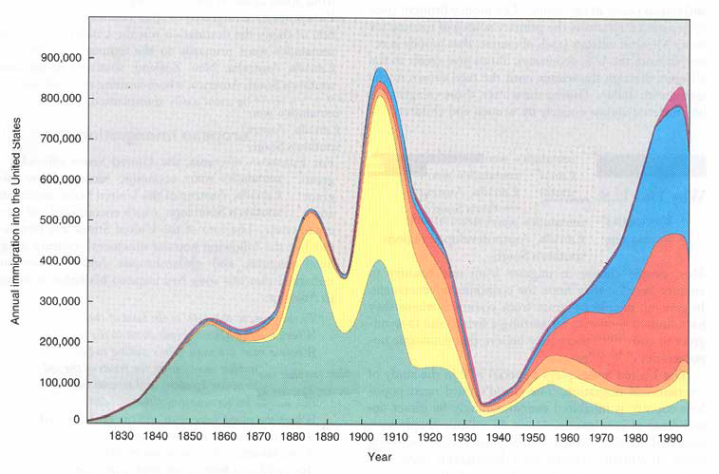

Now summarize the graph in a min of 7,896,448,011 words. (Well, how about 75 words instead?)
________________________________________________________________________________________________________________________________________________________________________________________________
________________________________________________________________________________________________________________________________________________________________________________________________
________________________________________________________________________________________________________________________________________________________________________________________________
________________________________________________________________________________________________________________________________________________________________________________________________
________________________________________________________________________________________________________________________________________________________________________________________________
- What are the 4 countries that sent out the most immigrants from Asia in recent years? ____________________________________
________________________________________________________________________________________________
- What caused immigration from Latin America to the United States to increase (cite real-world examples)?
________________________________________________________________________________________________
________________________________________________________________________________________________

- Although reasons people leave their countries to immigrate to the U.S. have not changed over time, what has changed here in the U.S.?
________________________________________________________________________________________________
________________________________________________________________________________________________
________________________________________________________________________________________________
________________________________________________________________________________________________
________________________________________________________________________________________________
________________________________________________________________________________________________
- Examine Figure 3-5 and 3-6:
List the Asian countries in order of number of immigrants to the US: ____________________________________________
________________________________________________________________________________________________________________________________________________________________________________________________
List the Latin Am. Countries in order of number of immigrants to the US: _________________________________________
________________________________________________________________________________________________________________________________________________________________________________________________

- Complete the chart below from info on page 94:

European Immigration
What were some of the causes of European immigration to the United States? | What were some of the important effects of European immigration to the U.S. and other world regions?

- What are undocumented immigrants? _________________________________________________________________________
- Where do most undocumented immigrants in the U.S. come from?
________________________________________________________________________________________________________________________________________________________________________________________________
________________________________________________________________________________________________________________________________________________________________________________________________
- Read Destination of Immigrants within the United States (pgs. 95-97) and annotate the map below. Be sure to indicate: Where are immigrants coming from? What states are those immigrants coming to?

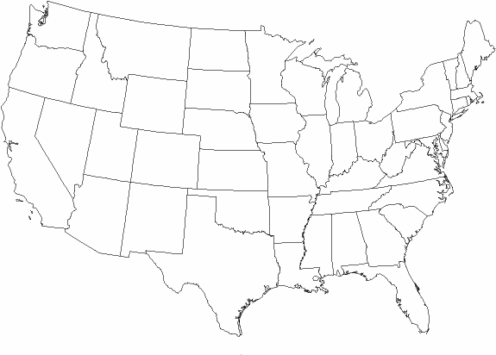

- Define chain migration and give an example:______________________________________________________________________

Key Issue 3 – Why do Migrants Face Obstacles? P. 97
- What did the Quota Act (1921) and the National Origins Act (1924) do?
________________________________________________________________________________________________________________________________________________________________________________________________
- How did they favor immigration from certain regions?
________________________________________________________________________________________________________________________________________________________________________________________________
- How did the Immigration Act of 1965 change the existing quota laws?
________________________________________________________________________________________________________________________________________________________________________________________________
- How was immigration law further changed in 1978? ________________________________________________________________ And presently? ___________________________________________________________________________________________
- U.S. immigration law gives preferences to three groups. Identify them. _________________________________________________
________________________________________________________________________________________________
- Define brain drain: and give an example: _________________________________________________________________________
________________________________________________________________________________________________
- Define guest worker and give an example: ________________________________________________________________________
________________________________________________________________________________________________

- Prepare notes on 3 case studies of immigration in the chart below.
Immigration to the U.S.: 3 Case Studies
Cuba | Haiti | Vietnam

9. Carefully read the section on Cultural Challenges. Then, complete the Venn diagram below to compare and contrast attitudes in the U.S. and
Europe toward immigrants.

U.S. Attitudes Toward Immigrants | European Attitudes Toward Guest Workers

Key Issue 4 – Why do People Migrate Within a Country?
- What is the most famous example of large-scale interregional migration in the U.S.? ______________________________________
- What is the “population center” (see Figure 3-12)? _______________________________________________________________
- What was the first “intervening obstacle” which hindered American settlement of the interior of the continent? _________________
- What developments in transportation eventually encouraged settlement to the Mississippi? _________________________________
- Why was settlement of the Great Plains slow to come with settlers passing it by for California and the west coast? _______________
________________________________________________________________________________________________
- How did the railroads encourage settlement of the American interior? __________________________________________________
- For what two reasons have people been migrating to the South in recent years? ___________________________________________
________________________________________________________________________________________________
- Use the chart on page 104 to calculate the net growth or loss of U.S. regions for 2007. Name the region on the map and place the appropriate number in each region.
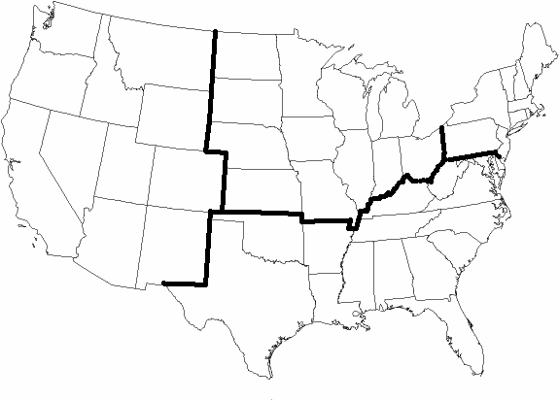

- Make appropriate notes in the chart below on 5 specific examples/case studies of interregional migration

Russia
Where? | Why?
How?

Brazil
Where? | Why?
How?

Indonesia
Where? | Why?
How?

Europe | India

- Define/describe each of the following terms, and summarize a single, important fact about its occurrence in the U.S.

 | Urbanization | Suburbanization | Counterurbanization
Definition
Significant Facts
in U.S.

